First look at Cumbernauld Theatre’s new festive show Ugly: A Cinderella Story
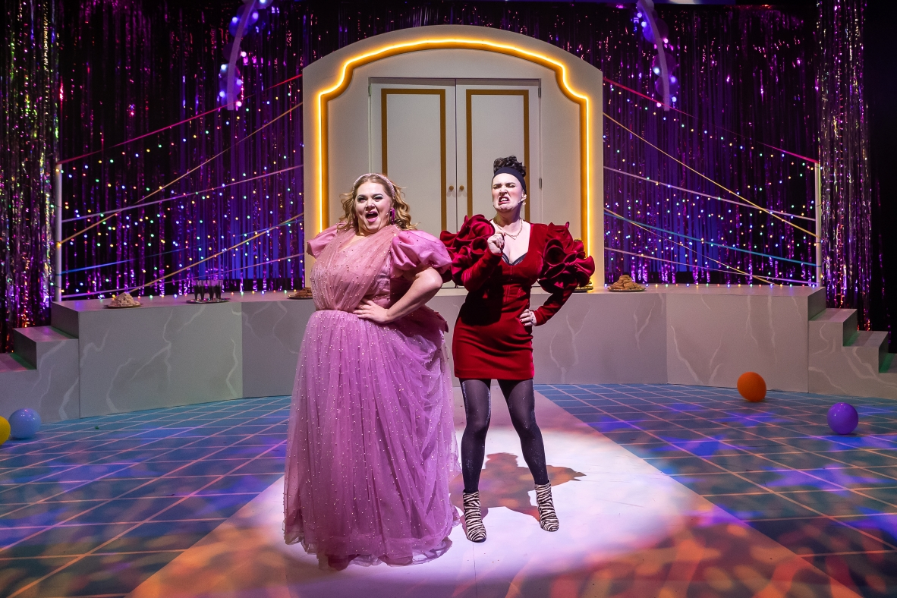
Lauren Ellis Steele and Jo Freer in Ugly: A Cinderella Story – pic by Sally Jubb
Production images available HERE
Cumbernauld Theatre is ready to transform into the magical Wondernauld with Ugly: A Cinderella Story, an unforgettable new spin on the classic Cinderella story from writer Gary McNair, opening this week.
Stuck on the sidelines of someone else’s story, the Ugly Sister is hackit, crabbit, and desperate for a change.
Across the ballroom, fresh from her success in glowing up Cinderella with a princess-worthy frock and fancy glass slippers, the Fairy Godmother is ready to kick back and enjoy another happy-ever-after. But finding herself stuck at the Wondernauld Christmas Ball, her fairy senses start a-tingling that there’s a wish still to be granted…
In this magical makeover journey, the Fairy Godmother and Ugly Sister must work together to achieve a transformation really worth doing and discover that true worth is on the inside, not the outside. But will the Ugly Sister accept the help she needs or has she been wearing this ‘ugly’ label too long to change?

Audiences young and old are invited to step into the magical world of Wondernauld for a festive treat that will have them laughing, singing, and dancing in the aisles.
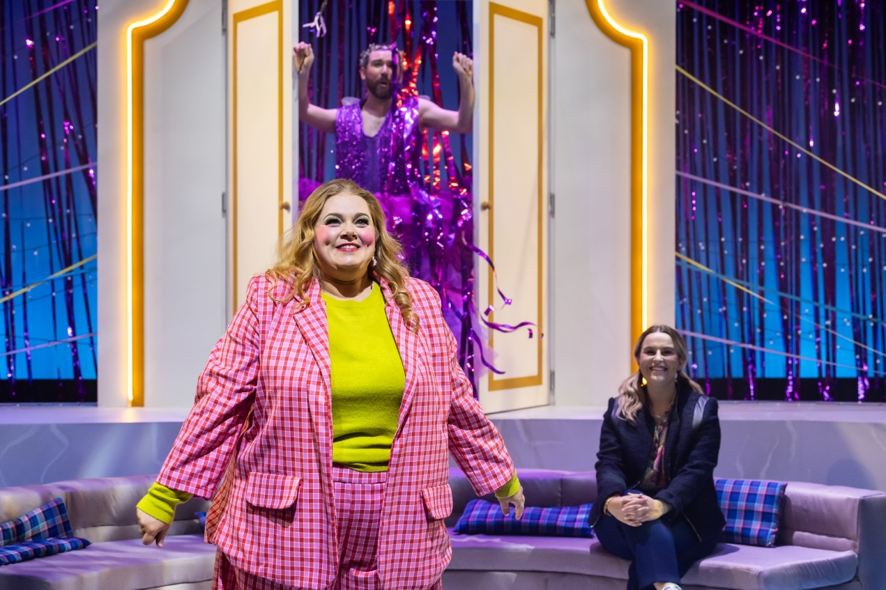
Lauren Ellis Steele, Laurence Boothman, and Eva Beattie in Ugly: A Cinderella Story – pic by Sally Jubb
The show is brought to life by a glittering cast of theatre talent including Lauren Ellis Steele as Chantelle, Jo Freer as Maw, Laurence Boothman as the Prince and Fairy Godmother, and Eva Beattie making her professional stage debut as Cinderella. Directed by Jo Rush, the production also features music by Brian James O’Sullivan.
Ugly: A Cinderella Story will run at Lanternhouse Main Auditorium from Sat 25 November to Sat 30 December, with an opening press performance on Fri 01 December at 7pm.
Meanwhile the Studio Theatre hosts a special production for younger audiences from Saturday 2 December to Saturday 30 December - A Ladder to the Stars, a heartfelt, humorous story of what can happen when the universe hears your dreams, produced by Visible Fictions.

ENDS -
-----------

Cast images and biogs can be found here.
For more information, contact:
Joseph Crerar-Blythe, The Corner Shop PR: joseph@thecornershoppr.com / 07500 258 404
Rachel Murphy, Communications & Engagement Manager, Cumbernauld Theatre: rmurphy@cumbernauldtheatre.co.uk / 01236 732887

Production info
Ugly: A Cinderella Story
Written by Gary McNair, Directed by Jo Rush, Music by Brian James O’Sullivan
Presented by Cumbernauld Theatre Company

Cast
Chantelle – Lauren Ellis Steele
Maw – Jo Freer
Fairy Godmother/Prince – Lawrence Boothman
Cinderella – Eva Beattie
Listings info

Sat 02 – Sat 30 December (preview performances Sat 25 Nov – Fri 1 Dec) | Times vary
Relaxed Performance on Sat 09 December (11am)
BSL/Audio Described Performance on Thu 21 December (7pm)
Ticket prices: £14 - £25
For a list of school performances please contact the box office on 01236 732887
For tickets and full listings information call the box office on 01236 732887 or visit lanternhousearts.org/events/ugly-a-cinderella-story

Cast Biographies
Lauren Ellis Steele (Chantelle)
Training: Glasgow Academy of Musical Theatre Arts
Theatre credits include: Scots (Oran Mor, NYC and Edinburgh Fringe Festival); Robin Hood (The Lanternhouse Theatre); The Wonderful Wizard of Oz, Cinderfella, Mammy Goose & Alice in Weegieland (Tron Theatre); Peter Gynt (National Theatre); MYTH: The Rise and fall of Orpheus (The Other Palace); Girls’ Night Oot! (UK Tour); Wicked (UK Tour).
Screen includes: Carly Bonner in 6 Degrees (BBC – 3 series); Chloe in The Crash (BBC).
Workshop includes: Thank You For Doing Nothing (Silent Uproar); Cinderella (Dundee Rep); Hen Night Horror; Peter Gynt (National Theatre); Our Ladies of Perpetual Succour (National Theatre of Scotland).
Jo Freer (Maw)
Jo trained at the RCS. Since then, she’s been lucky enough to work for lots of brilliant companies. Her theatre work includes, The Steamie, The Cheviot, The Stag and The Black, Black Oil, Sunshine on Leith, The Witches, Midsummer, Much Ado About Nothing (Dundee Rep), Let The Right One In, House of Bernarda Alba, Mary Queen of Scots Got Her Head Chopped Off, Our Teacher's a Troll, Submarine Time Machine (National Theatre of Scotland), The Alchemist, Cinderfella and Alice in Weegieland (The Tron Theatre Co). Trumpets and Raspberries, Cinderella (The Royal Lyceum) Little Shop of Horrors, Absurd Person Singular, Communicating Doors, Amadeus (Pitlochry Festival Theatre) First Dance, The company will overlook a moment of madness, When the penny drops and Made in China (A play, a pie and a pint)
Television work includes, Scot Squad, River City and Doctors (BBC) and Emmerdale (ITV).
Lawrence Boothman (Fairy Godmother/Prince)
Lawrence holds an MA in Acting from the Royal Conservatoire of Scotland, thanks to an RCS Scholarship and the John Mather Trust Award. His stage credits include: Filov in The Brief Life & Mysterious Death of Boris III, King of Bulgaria (Arcola Theatre), Emile in The Devil Drinks Cava (A Play, A Pie & A Pint), Cassius in Julius Caesar (Scottish Tour) and Lebeau in Arthur Miller’s Incident At Vichy (Finborough Theatre).
Eva Beattie (Cinderella)
Eva graduated with a BA in Musical Theatre from New College Lanarkshire in 2020.
Her theatre credits there include Gertrude in Seussical the Musical, Zombie Prom, and Beauty and the Beast (pantomime). She is super excited to be taking on the role of Cinderella in this production!
Eva also teaches at two theatre groups in Kilmarnock and Cumnock.

Notes for editors
Cumbernauld Theatre Trust
Cumbernauld Theatre Trust is a performing arts charity that produces and presents professional theatre, music, dance and comedy experiences for a community of 50,000 Cumbernauld residents and 100,000 North Lanarkshire population. Established in 1963, Cumbernauld Theatre is the only professional independent arts organisation in Cumbernauld and North Lanarkshire and serves a vital social, cultural and economic purpose in a community that is economically disadvantaged, with widespread material poverty and deprivation, low academic attainment and poor-quality built environment.
As an established, professional producing theatre, we are both community-led and community conscious with activity that responds to the needs of the local community, yet we deliver outputs that achieve national and international recognition.
We aim for our work to have relevance and resonate with our audiences and participants to achieve deep and lasting impact and change. This work is informed by place, by the opportunities our new arts centre provides and by a desire to deliver affordable access to culture for everyone at all life-stages. Cumbernauld Theatre Trust is a key part of the infrastructure of Scotland’s performing arts and is a Regularly Funded Organisation (RFO) within the Creative Scotland portfolio. We receive investment in support of our work from a range of sources including Creative Scotland and North Lanarkshire Council, Weston Culture Fund and Scottish Government’s Empowering Communities Programme – Investing in Communities Fund.
Cumbernauld Theatre Trust is also supported by Screen Scotland, Equity Charitable Trust, Foyle Foundation, The Levenseat Trust, The Trades House of Glasgow Commonweal Fund, Land Trust, Robert Barr’s Charitable Trust, Hugh Fraser Foundation, The Robertson Trust and Patersons Quarries, our Friends, and donors.
Lanternhouse is a privately-owned property built through Scottish Futures Trust (SFT) investment jointly operated by North Lanarkshire Council (NLC) and Cumbernauld Theatre Trust. The construction of Lanternhouse was financed via the SFT-managed hub community infrastructure programme for local authorities in support of the Scottish Government’s National Infrastructure Mission to drive inclusive economic growth and build resilient places. For more information visit https://www.scottishfuturestrust.org.uk/.
http://www.lanternhousearts.org/ | info@lanternhousearts.org
Cumbernauld Theatre Trust Ltd is a Registered Company limited by guarantee No. SC066490, Scottish Charity OSCR Registered No. SC005050. Registered Office: Cumbernauld Theatre Trust, Lanternhouse, South Kildrum Ring Road, Cumbernauld, North Lanarkshire, G67 2UF
Lanternhouse is a registered trademark (UK00003494622) owned by Cumbernauld Theatre Trust Ltd.

